How to update DX471 via SD card
- Get the FW update package for DX471
- Copy the FW to the root directory of SD card(SD card should not over 32G)
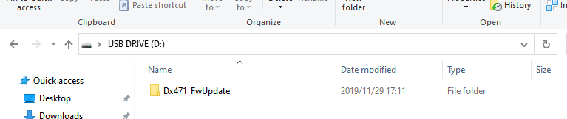
- Insert the SD card with the FW file
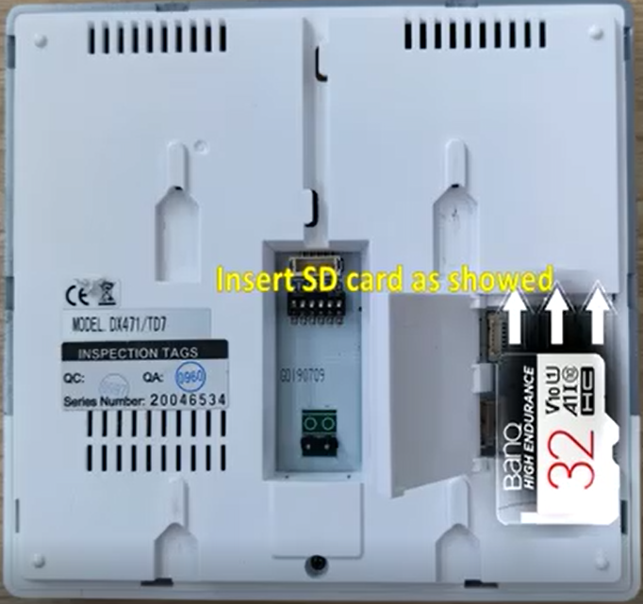
- Power on DX471 and tap “Settings” -> “General” -> “SD card” -> “firmware update”, please also do use default after updating: setting-->wireless-->use default

